Basics Of Artificial Intelligence – IE

Eye Blink Detection using ESP32

Abstract -In recent times, eye monitoring and blink detection are increasingly more popular amongst researchers and feature the ability to end up a greater important element of future perceptual person interfaces. The real-time eye-monitoring system has been a fundamental and hard hassle for system studying troubles. the principle cause of this paper is to advocate a brand new approach to design an embedded eye blink detection device that can be used for numerous packages with the bottom cost. This examine provides an efficient approach to determine the level of eyes which can be closed and opened. We offered a actual-time blink detection approach by means of using machine learning and computer vision libraries and incorporated it with ESP32 cam module.
Keywords— ESP 32 cam module, computer vision, eye blink detection system

Introduction
One of the most crucial features of the human face are eyes, which play a critical role within the generation of facial expressions. The evaluation of the eye movement dynamics not only allows to evaluate the human expressions however additionally allows to examine the influence of external elements on the change of human emotional states.
Recent improvements in the subject of computing technology have paved the way for many innovations within the discipline of Human computer interaction (HCI) using eyes as a new medium for interaction has won greater reputation over the past few years. This paper offers a novel technique for eye tracking and blink detection inside the video frames acquired from the ESP32 cam module. It uses a method involving Haar cascade classifier for eye monitoring. The provided approach is non-intrusive and for this reason provides a comfortable consumer interaction

Methodology

Here’s a block diagram of the designed system
Capturing Video
Frames
Face Detection And
Extraction
Eye Region
Extraction
Eye Detection

Capturing Image
The first stage is the capturing of the video frames. The video frames are captured using ESP32 cam module and sent to a server using hotspot. We can access the live video from the server by the link provided. For eye tracking and blink detection each of these frames are extracted and processed individually.

Face detection and extraction
The image frames captured by the ESP32 cam module contains the user’s faces along with the background. Hence, it is necessary to detect and extract the face of the user in each frame. Face detection method developed by Viola and Jones is used in this paper.
The Viola-Jones face detection method makes use of Haar-like features. The Haar-like features are extracted using a set of templates. Each template is characterized by a group of rectangular black and white regions. A large number of Haar-like features can be extracted from the image using the above templates.
When a region of an image is taken it is first checked using the haar cascade classifier. Only if the image region is classified as containing a face it will be passed else it will be discarded. This detected face image is sent to the next stage for further processing.
C. Eye Region Extraction
This is done by making use of the geometry of the human face. A geometric ratio is followed in human face for the arrangement of facial features. If ‘h’ is the total heighr of the face then the eyes are placed between the distances 0.2h to 0.6h from the top of the head
D. Eye Detection
Eyes are detected from the extracted eye regions. Both the left and right eye regions are extracted and processed separately. Haar based cascade classifier is used again in this stage. But this detection method fails when the eyes are closed. Insuch situations the eyes images are cut out from the positions of eyes in the extracted eye region from the preceding frame in the video sequence

COMPONENTS

Following is the list of materials required for building an ESP32 based Eye Blink Detection system.
Sr. No. | COMPONENTS | DESCRIPTION
1. | ESP32 – CAM Board | AI – Thinker ESP 32 Camera Module
2. | FTDI Module | USB – to – TTL  Converter Module
3. | USB Cable | 5V Mini-USB Data Cable
4. | Jumper Wires | Male to Male,  Male to Female,  Female to Female Connectors

ESP32 – CAM FDTI Connection
The board doesnt have a programmer chip. So in order to program this board, an FDTI Module is used. Make the following connection between FDTI Module and ESP 32 CAM Module.
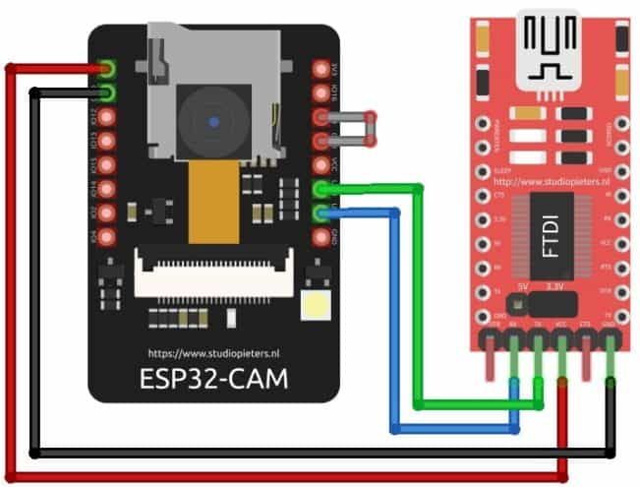
ESP 32 CAM | FDTI Programmer
GND | GND
5V | VCC
U0R | TX
U0T | RX
GPIO0 | GND

PRESETS
The equations are an exception to the prescribed. Before uploading the arduino code, change the SSID and password variable in accordance with your WiFi network
Now compile and upload it to the ESP32 CAM board. But during uploading make sure to follow these few steps every time
- Make sure the 1O0 pin is shorted with the ground while pressing the upload button
- If you see the dots and dashes while uploading press the reset button immediately
- Once the code is uploaded, remove the IO0 pin shorting the ground and press the reset button again
- If the output is the Serial Monitor is still not there then press the reset button again

RESULTS AND DISCUSSIONS

The video frames for processing are obtained from an ESP 32 Cam Module. Since the captured video is as an array of video frames (images), each of these image frames are separated and processed individually. Then the face is detected from the image using Haar based cascade classifier. The classifier classifies the frames into portions that contain a face and into that does not contain a face. The portion containing a face is extracted and thus the faces are detected. The geometrical properties of human face are computed, in the face image extracted from the video frame. This extracted eye region is then separated into two regions by cutting exactly at the center. After that just like the face detection is performed by the Haar based cascade classifiers, these are used for detection of eyes from the eye region. With the extraction of the eyes, the eye tracking algorithm is completed

E) FUTURE SCOPE AND CONCLUSION
Eye tracking and blink detection have found its applications in areas ranging from user interface designs to driver drowsiness detection.
The eye movement analysis is also an area of research related with the mental condition of humans. The dynamics of eye movements may indicate fatigue, drowsiness, focusing difficulties, eye strain or its irritation. Therefore, the auto- matic analysis of eye movements based on computer vision algorithms can help improve the productivity, efficiency and concentration of workers through better management of time allocated to rest can reduce the number of car accidents caused by falling asleep while driving, or can be used as a tool to communicate, for people with limited mobility

References
- B. R. Ibrahim et al., "Embedded System for Eye Blink Detection Using Machine Learning Technique," 2021 1st Babylon International Conference on Information Technology and Science (BICITS), 2021, pp. 58-62, doi: 10.1109/BICITS51482.2021.9509908.

- K. Malik and B. Smolka, "Eye blink detection using Local Binary Patterns," 2014 International Conference on Multimedia Computing and Systems (ICMCS), 2014, pp. 385-390, doi: 10.1109/ICMCS.2014.6911268.

- Qiang Ji, Zhiwei Zhu and P. Lan, "Real-time nonintrusive monitoring and prediction of driver fatigue," in IEEE Transactions on Vehicular Technology, vol. 53, no. 4, pp. 1052-1068, July 2004, doi: 10.1109/TVT.2004.830974.

Rishabh Tiwari, 57
Yoshit Verma, 58
Vedanti Wadekar, 59
Nidhi Worah, 60

